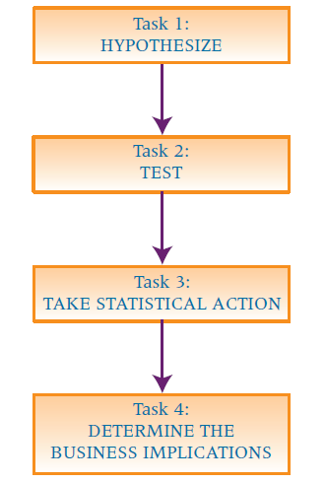

eight-step approach:

■ Step 1. Establish a null and alternative hypothesis.

■ Step 2. Determine the appropriate statistical test.

■ Step 3. Set the value of alpha, the Type I error rate.

■ Step 4. Establish the decision rule.

■ Step 5. Gather sample data.

■ Step 6. Analyze the data.

■ Step 7. Reach a statistical conclusion.

■ Step 8. Make a business decision.

